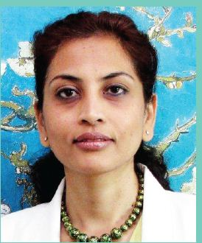

Dr. Asha Bakshi
Senior Consultant Neurosurgeon,
Department of Neurosciences, Neurospine Unit

Experience:

Dr. Asha Bakshi is a brilliant and dynamic neurosurgeon having done MBBS from Madras University and DNB-Neurosurgery from Army Hospital, R&R, Delhi.

- Fellowship Neuroendoscopic Surgery from Mainz, Germany, 1998

- Fellowship Neurovascular surgery from Nagoya University, Japan, 1999-

- Observership- Interventional Neuroradiology from OHSU, Portland, USA

- Postdoctorate Fellowship in Stem Cell Research, Dept. of Neurosurgery, University of Pennsylvania, USA

- Stem Cell Research Scientist, Department of Neurology, AIIMS, Delhi

- Worked as consultant Neurosurgeon at VIMHANs, Delhi, Fortis-Escorts Faridabad, Sagar-Apollo, Bangalore, Indian Spinal Injuries Centre, Delhi and as Assistant Professor, Neurosurgery, SRMC, Chennai.

Contribution & Interests:

Minimally Invasive Neurosurgery: At VIMHANS, Delhi, Dr. Bakshi conducted workshops in Neuroendoscopy and initiated interventional neuroradiology. At Sagar-Apollo, she started an active interventional stroke programme.

At AIIMS, she co-authored the National Guidelines for stroke management

Stem Cell Therapy- She was involved in a DBT funded multicentric clinical trial across the country for stem cell therapy in stroke patients. At ISIC, she was involved in the ICMR project fro stem cells in spinal cord injury patients.

Research & Academics:

- Teaching as Assistant Professor, Neurosurgery, Sri Ramachandra Medical College, Chennai

- Postdoctorate in stem cell Research, UPenn, USA - researching on stem cell therapy for brain/spine injuries, stroke, tumors and parkinsons disease

- Research Associate, AIIMS -clinical trials

for stem cell therapy in stroke patients in the Dept. of Neurology.

- Editorial Reviewer, Neurology India. Member of NSI, DNA, ISA

